Displaying data from multiple tables using joins

- Write a query for the HR department to produce the addresses of all the departments. Use the EMP and DEPT tables. Show the EMPNO, ENAME, SAL, DNAME and LOC in the output. Use a NATURAL JOIN to produce the results.

SELECT EMPNO, ENAME, SAL, DNAME, LOC
FROM EMP
NATURAL JOIN DEPT;

Output:-



- The HR department needs a report of all employees. Write a query to display the JOB, MGR, SAL, COMM, DNAME of employees whose JOB is SALESMAN.

SELECT JOB, MGR, SAL, COMM, DNAME
FROM EMP, DEPT
WHERE EMP.DEPTNO = DEPT.DEPTNO
AND JOB = 'SALESMAN';

Output:-

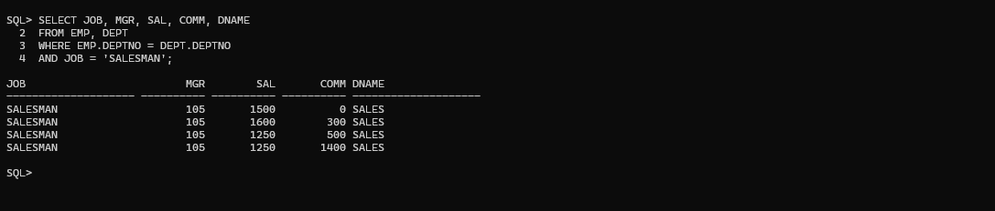

- The HR department needs a report of employees in LOC DALLAS. Display the ENAME, JOB, DEPTNO, and DNAME for all employees who work in DALLAS.

SELECT ENAME, JOB, EMP.DEPTNO, DNAME
FROM EMP, DEPT
WHERE EMP.DEPTNO = DEPT.DEPTNO
AND LOC = 'DALLAS';

Output:-

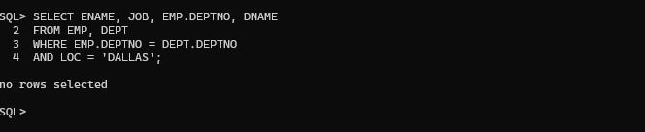

- Create a report to display employees' name and employee number along with their manager's name and manager number. Label the columns Employee, Emp#, Manager, and Mgr#, respectively.

SELECT E.ENAME as Employee,
E.EMPNO as Emp#,
M.ENAME as Manager,
M.EMPNO as Mgr#
FROM EMP E, EMP M
WHERE E.MGR = M.EMPNO;

Output:-

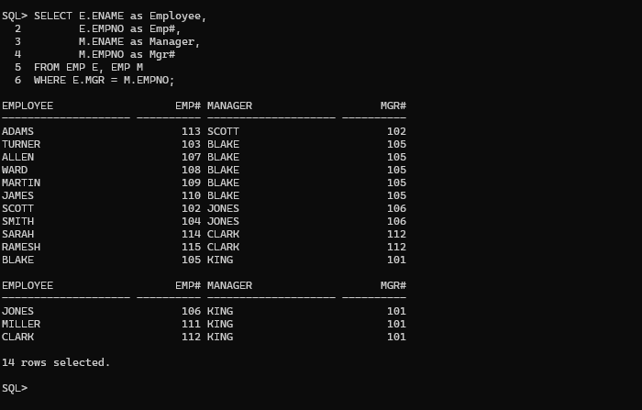

- Modify the previous query to display all employees including King, who has no manager. Order the results by the employee number.

SELECT E.ENAME as Employee,
E.EMPNO as Emp#,
M.ENAME as Manager,
M.EMPNO as Mgr#
FROM EMP E, EMP M
WHERE E.MGR = M.EMPNO(+)
ORDER BY E.EMPNO;

Output:-

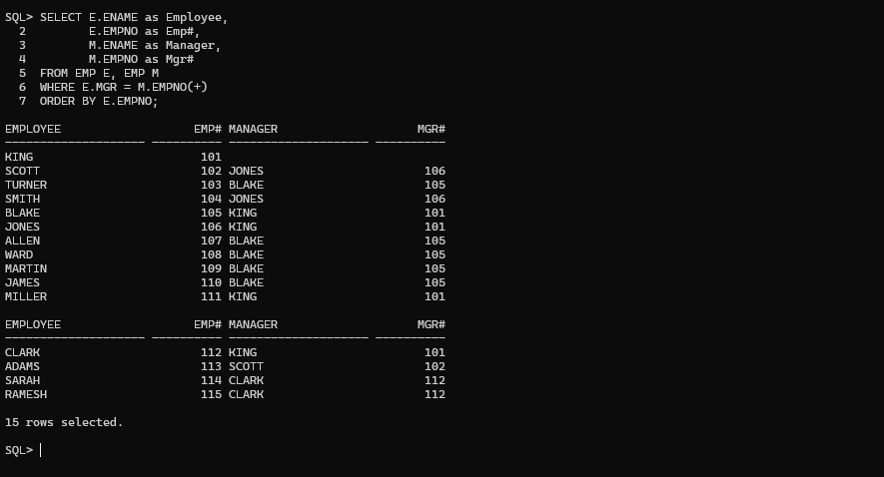

- The HR department needs a report on job grades and salaries. To familiarize yourself with the SALGRADE table, first show the structure of the SALGRADE table. Then create a query that displays the name, job, department name, salary, and grade for all employees.

Describe SALGRADE;

Output:-

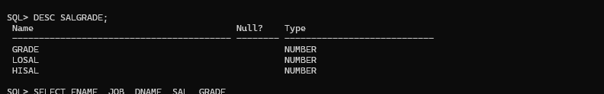

SELECT ENAME, JOB, DNAME, SAL, GRADE
FROM EMP, DEPT, SALGRADE
WHERE EMP.DEPTNO = DEPT.DEPTNO
AND SAL BETWEEN LOSAL AND HISAL;

Output:-

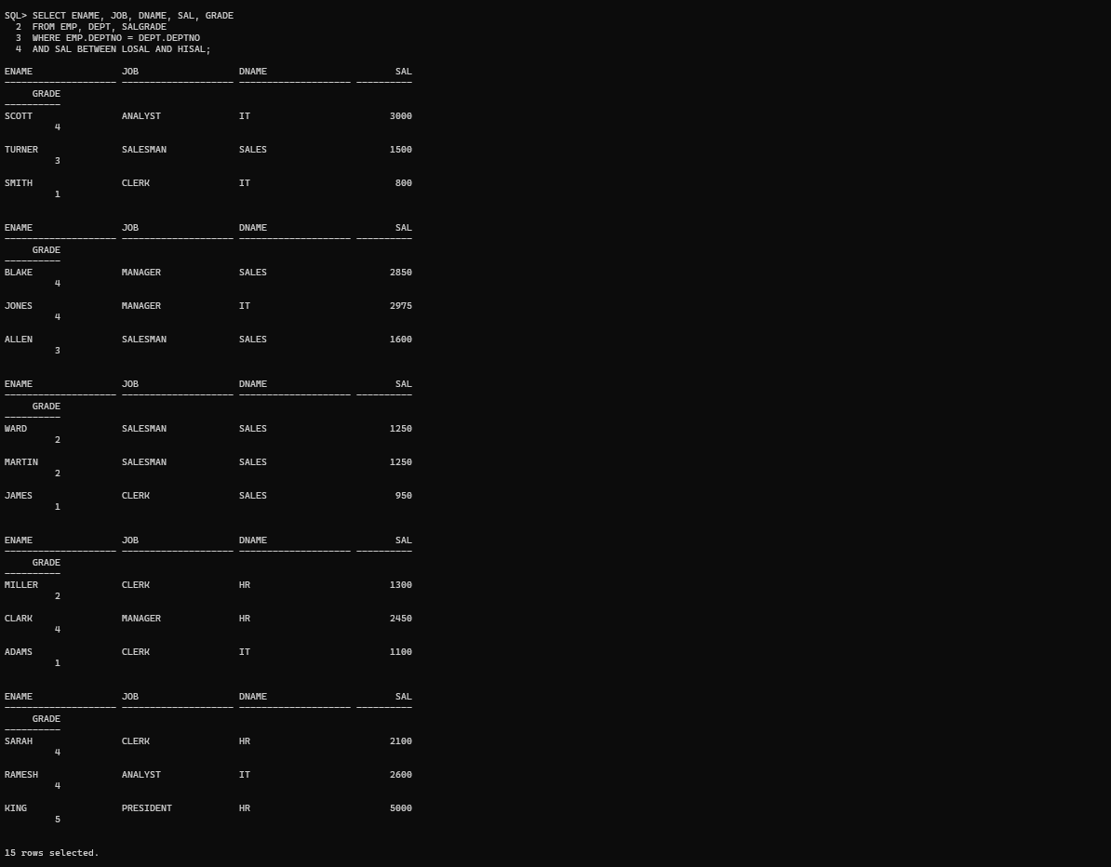

- Display the ENAME, DNAME of all the employees. Also display those department name which do not have any employees working.

SELECT ENAME, DNAME
FROM EMP, DEPT
WHERE EMP.DEPTNO(+) = DEPT.DEPTNO;
Output:-

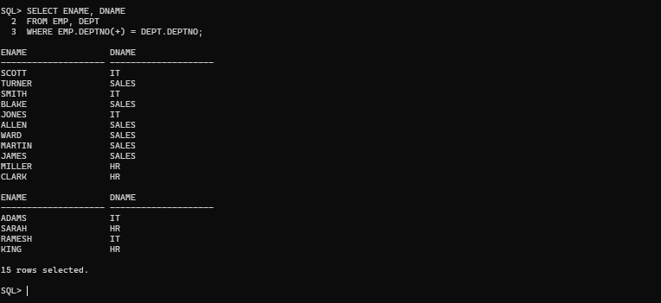

- The HR department needs to find the names and hire dates for all employees who were hired before their managers, along with their managers' names and hire dates.

SELECT E.ENAME,
E.HIREDATE,
M.ENAME,
M.HIREDATE
FROM EMP E, EMP M
WHERE E.MGR = M.EMPNO
AND E.HIREDATE < M.HIREDATE;

Output:-

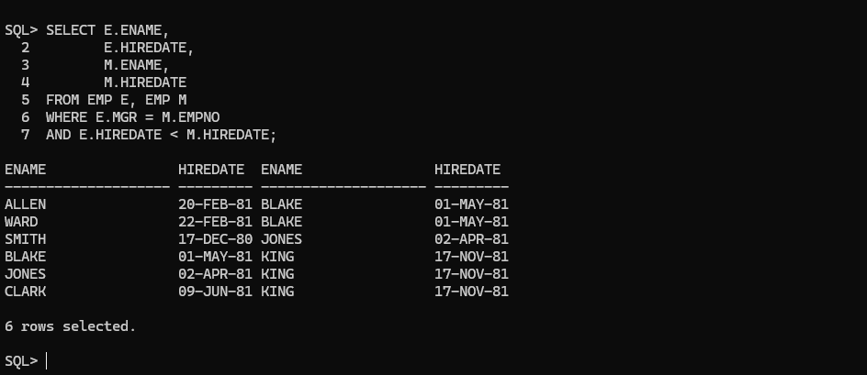
- Display the EMPNO, ENAME, DNAME, LOC of those employees who are working as CLERK. Use the USING clause.

SELECT EMPNO, ENAME, DNAME, LOC
FROM EMP
JOIN DEPT
USING (DEPTNO)
WHERE JOB = 'CLERK';

Output:-

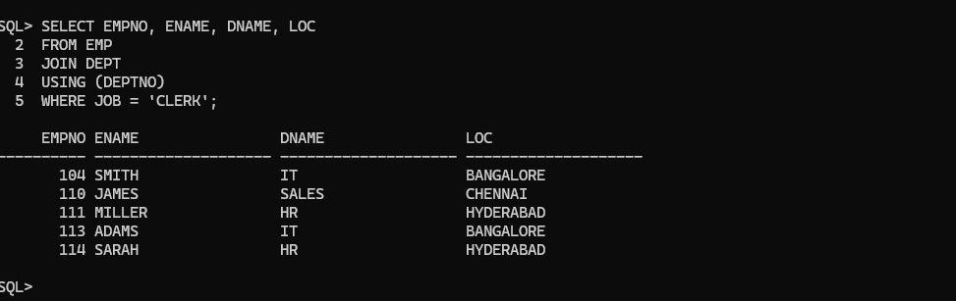

- Display the ENAME, SAL, MGR, DNAME of employees whose salary is more than 2000. Use the ON clause.

SELECT ENAME, SAL, MGR, DNAME
FROM EMP
JOIN DEPT
ON EMP.DEPTNO = DEPT.DEPTNO
WHERE SAL > 2000;

Output:-

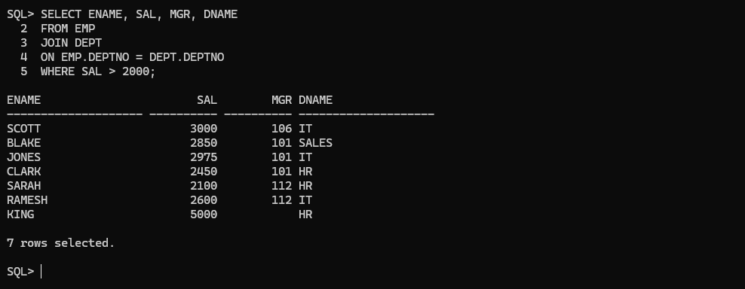

- Display the EMPNO, ENAME, JOB, DEPTNO, DNAME, LOC of employees. Use LEFT OUTER JOIN.

SELECT EMPNO, ENAME, JOB, EMP.DEPTNO, DNAME, LOC
FROM EMP
LEFT OUTER JOIN DEPT
ON EMP.DEPTNO = DEPT.DEPTNO;

Output:-



- Display the ENAME, DNAME of employees. Use RIGHT OUTER JOIN.

SELECT ENAME, DNAME
FROM EMP
RIGHT OUTER JOIN DEPT
ON EMP.DEPTNO = DEPT.DEPTNO;

Output:-

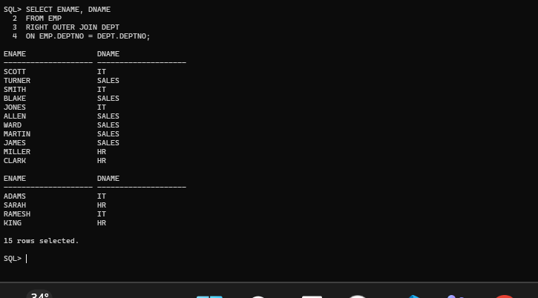

- Display the EMPNO, DNAME, LOC of employees. Use FULL OUTER JOIN.

SELECT EMPNO, DNAME, LOC
FROM EMP
FULL OUTER JOIN DEPT
ON EMP.DEPTNO = DEPT.DEPTNO;

Output:-

